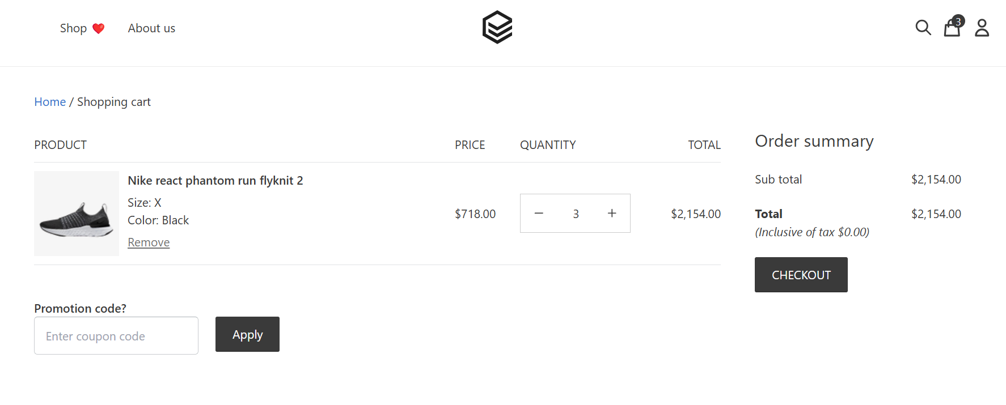1. Filters are not working correctly. When size S is being selected and it always shows size X in the view cart page.